Company name: Itella Logistics, UAB
A part of international Finnish logistics company POSTI with headquarters in Helsinki
Legal address: Pirklių g. 5, LT-02300 Vilnius, Lithuania
Terminal address: Terminalo g. 10, LT-54469 Biruliškės village, Karmėlava eldership, Kaunas district, Lithuania
Territory of activity: Itella Logistics, UAB provides services in European and Scandinavian countries
Applicable standards: ISO 9001:2015, ISO 14001:2015
Exception: design is not a part of service performance process, therefore, the exception with respect to Clause 8.3 “Design” of the standard ISO 9001:2015 is applied
Main activity: Logistics solutions for road, sea and air transport, warehousing and other contract logistics services
We operate in the following sectors:
- postal communications;
- information logistics;
- materials logistics.

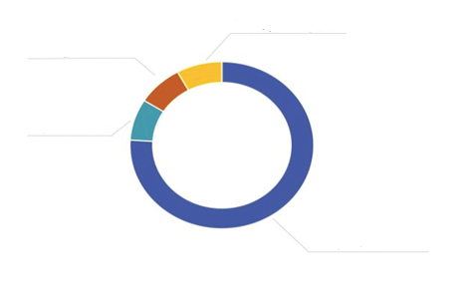
Warehousing
Parcel delivery
Road freight
Transport by sea and air

Our main clients:
- retail companies;
- wholesale companies;
- production sector;
- online stores.

On the basis of the international standards ISO 9001:2015 and ISO 14001:2015, Itella logistics, UAB has developed, documented, implemented and maintains quality and environmental management systems (hereinafter – QMS) and continually improves its performance in accordance with the requirements of international standards. Quality and environmental management system covers the following:
- local and international freight transportation by road;
- parcel delivery on local and international routes;
- freight transport by air and sea;
- warehousing services and all value added services during the storage of goods;
- customs clearance.

The requirements of an integrated management system are binding to every employee in the organization and cover all environmental aspects that the organization can control, including management of identified dangers and risk mitigation measures. The implemented management system ensures continuous efficiency improvement.
The management of the company, on behalf of all employees, undertakes to apply the principles of pollution prevention in order to reduce the environmental impact of its activities. These obligations are defined in the company’s integrated management system policy.

Further information about the company’s business activity: http://www.itella.lt

